**Python Additional Exercises 1**

Accept an employee’s annual salary and then calculate and display his/her net monthly salary. Full time employees pay 29.5% income tax. All other employees pay 25% income tax. Display the gross monthly salary, percentage tax, monthly tax payable and net monthly salary as output. • Identify all input and output variables and draw an IPO-chart for this problem

• Design two sets of test data and test if your logic works correctly. • Write the solution in Python and provide for the following: Data validation. Use a Boolean variable to test if the annual salary can be converted to a decimal value. If not, display the message \. Format all output fields in a suitable way.

**Python Additional Exercises 2**

The Bright Light Company is increasing the salaries of their employees according to their department as can be seen in the table below.

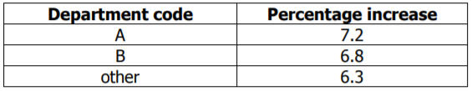

Do the planning and write an algorithm to solve this problem. The user has to enter the department code and the current annual salary of the employee. Calculate and display the increased monthly salary. Use a nested if statement without AND and/or OR. Ensure that all data entered are correct. The IPO table below assists you to solve the above problem.

